good afternoon ma'am

You had asked about the concept I am trying to use

I am trying to train a AI model with supervised learning using labeled data set.

After training the model will take input a link or list of links and predict if any of the provided link is malicious.We need to update the training data-set regularly so that our model can be able to detect latest malicious link too.  
  
The problem is source of data-set. I am not able to get any good source of labeled data-set.

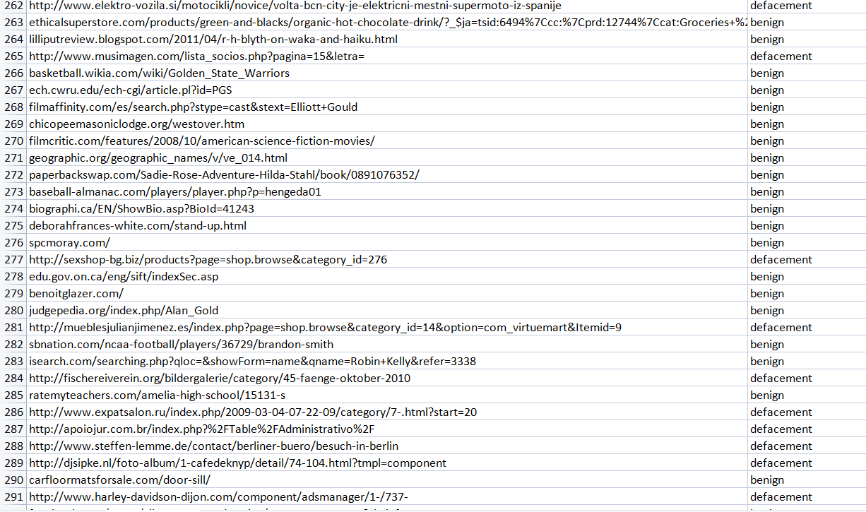

This is the data-set I have got from kaggle this can be useful for large number of links testing but not adequate for latest malicious links.